Implementation of Software to Support Operation of Driverless Car

This project is a Python-based implementation of driverless car system. It is divided into three modules: Lane Detection, Object Detection, and Navigation & Control. Each module is responsible for a specific aspect of the autonomous car’s functionality.

Module 1: Lane Detection

The Lane Detection module uses OpenCV to detect lanes in an image. The module reads an image, preprocesses it by converting it to grayscale and applying Gaussian blur, detects edges using the Canny edge detection method, defines a region of interest, detects lanes using the Hough transform, and finally draws the detected lanes on the image (Faisal et al, 2021).

Module 2: Object Detection

The Object Detection module uses TensorFlow and TensorFlow Hub to detect objects in an image. The module loads a pre-trained SSD MobileNet V2 model from TensorFlow Hub, prepares the input image, applies the model to the image, interprets the model output to get the bounding boxes and class labels, and visualizes the output (Reddy, 2019).

Module 3: Navigation and Control

The Navigation and Control module uses L5Kit and PythonRobotics to handle navigation and control. The module loads and preprocesses sensor data, performs object detection and segmentation on the sensor data, generates a bird’s eye view (BEV) image of the scene, plans a feasible and optimal path for the autonomous car to follow, tracks the planned path using a suitable control algorithm, and simulates the autonomous car behavior using a realistic environment ‌(Kalliomäki, 2019).

Installation

To run this project, you need to have Python installed on your machine. You can then install the required libraries using pip:

pip install opencv-python

pip install tensorflow

pip install tensorflow-hub

pip install l5kit

pip install PythonRobotics

(Reddy, 2019)

Usage

To use this project, we will need to run each module separately. For example, to run the Lane Detection module, we would do:

Python

detector = LaneDetector()

image_path = "path_to_your_image"

image = detector.read_image(image_path)

And then call the necessary functions to preprocess the image, detect edges, define the region of interest, detect lanes, and draw lanes.

Testing and Results

This project has been tested to ensure quality of performance and reliability.

Unit Testing

I have implemented unit tests as part of our development process. The unit tests are contained in the unit_test.py file. These tests cover all the major functions and algorithms in my program, ensuring that each component works as expected independently.

Lane Detection System

The lane detection system is a crucial part of the driverless car functionality. It works by processing images from the car’s cameras and applying several transformations to detect the lanes on the road. Here are some examples of the lane detection process:

**Original Image**: This is the raw image captured through simulated cv2.

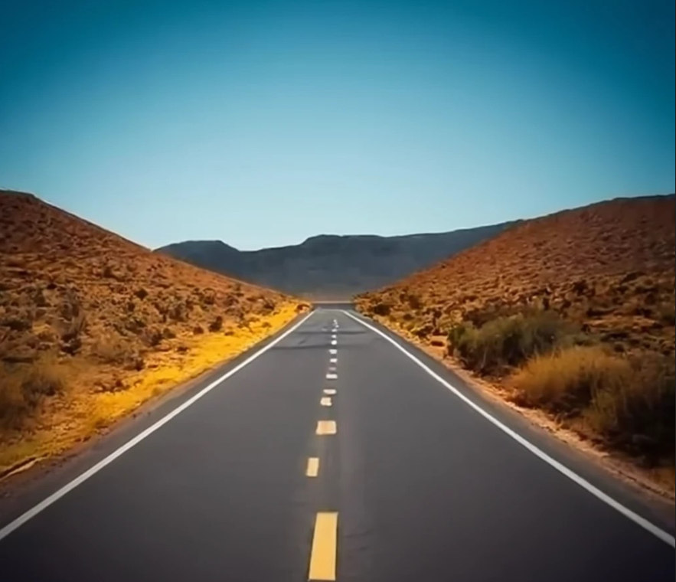

**Processed Image**: This image shows the result after applying transformations such as Gaussian blur and graying. The lanes on the road are clearly visible and can be used by the car to navigate.

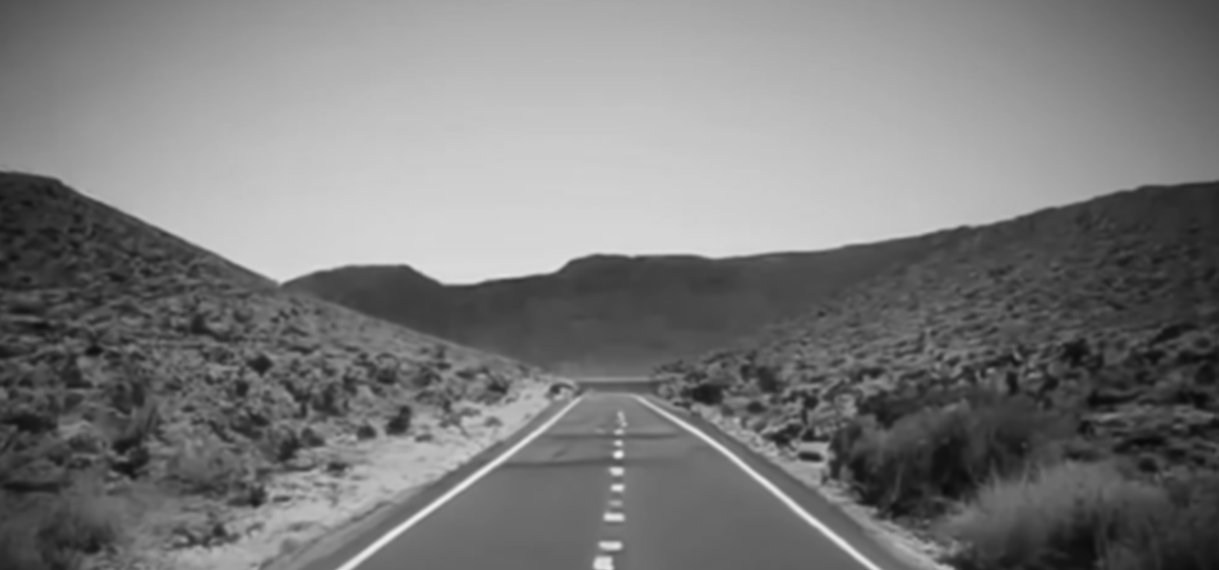

**Object Detection**

The object detection system processes the images and draws rectangles around the detected objects.

**Original Image**: This is the raw image loaded.

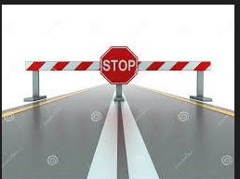

**Processed Image**: This image shows the result after the object detection system has identified objects. The detected objects are highlighted with rectangles.

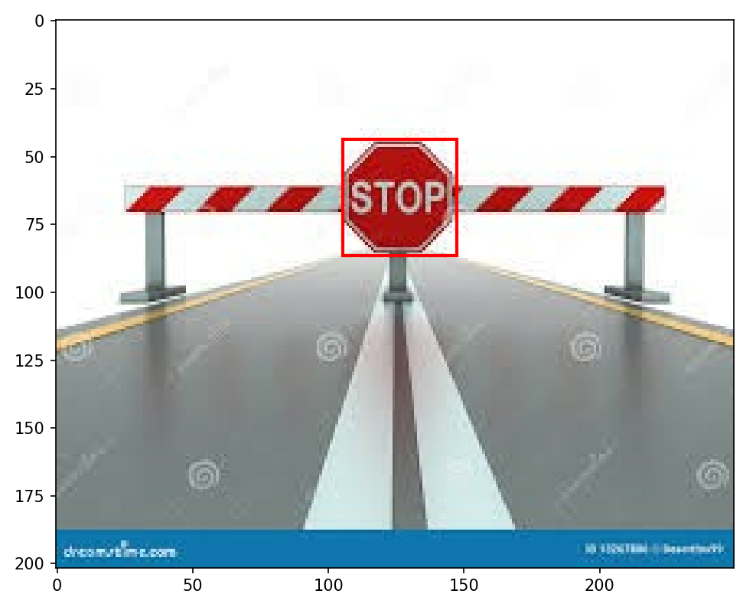

By providing these before and after images, the aim is to demonstrate the effectiveness of the image processing algorithms in real-world driving scenarios.

**References**

Ballew, G. (2017). *OpenCV For Lane Detection in Self Driving Cars*. [online] Medium. Available at: <https://medium.com/@galen.ballew/opencv-lanedetection-419361364fc0>.

CodeProject. (2018). *A Complete Guide to Self Driving Car*. [online] Available at: https://www.codeproject.com/Articles/1273179/A-Complete-Guide-to-Self-Driving-Car.

Reddy, P.P. (2019) Driverless Car : Software Modelling and Design Using Python and Tensorflow. *easychair.org*. [online] Available at: https://easychair.org/publications/preprint/k7wj.

Faisal, M., Reddy, G., Kumar, B. and Ajitha, D. (2021). Lane Line Detection for Autonomous Cars using Python and OpenCV. *IOSR Journal of Engineering (IOSRJEN) www.iosrjen.org ISSN*, [online] 11, pp.2278–8719. Available at: https://www.iosrjen.org/Papers/vol11_issue6/G1106015460.pdf

‌Kalliomäki, R. (2019). *Real-time object detection for autonomous vehicles using deep learning*. [online] Available at: https://www.diva-portal.org/smash/get/diva2:1356309/FULLTEXT01.pdf

‌